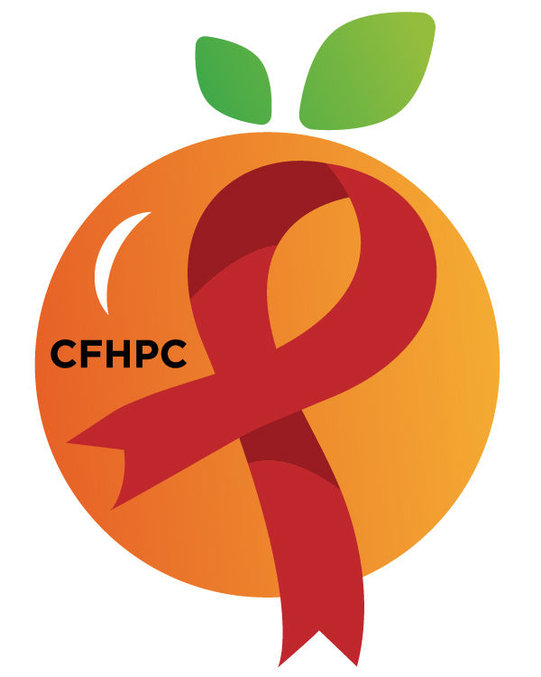

PR & Marketing Committee Agenda
Please silence all cell phones and keep usage to a minimum
Only the PLWH/A Representatives need to disclose their HIV status.
all meetings are audio recorded

January 14th, 2019

Heart of Florida United Way
10:30 AM | Call to Order  Welcome, Housekeeping & Introductions  Moment of Silence |  | Roy Harry
 | Vision Statement  Mission Statement  Conflict of Interest  Core Values |  | Aaron Sanford-Wetherell
 | Approval of Agenda  Approval of November 12th Minutes |  | Roy Harry
 | Roberts Rules Overview |  | PCS
10:45 AM | Open the floor for Public Comment  Mini Training:  1. Educational Infographics |  | All Members  Andres Acosta
 | Unfinished Business  Educational Infographic Team  World AIDS Day Event  Social Media Review  - Goals for 2020  Red Ribbon Times Newsletter | Purpose  Discussion  Recap  Update | David Bent and All Members  All Members
12:00 PM | New Business  Marketing Plan  Recruitment P&P  2020 Recruitment Activities  Set February’s Agenda | Purpose  Discussion  Review/Update  Discussion | All Members
 | Announcements  Leadership Evaluations  Next Month’s Meeting: February 11, 2020 | at HFUW
12:30 PM | Adjournment
Mission: To improve the quality of life of individuals with HIV disease by responding to their existing and emerging needs, and to provide educational and behavioral strategies to reduce and prevent the spread of HIV disease.
Please join my meeting from your computer, tablet or smartphone.
Go To Meeting: https://global.gotomeeting.com/join/218791973
Teleconference Line: United States: +1 (571) 317-3112 Access Code: 218-791-973
Planning Council Support
David Bent 407-835-0906 David.Bent@hfuw.org
Melanie Cross 407 429-2216 Melanie.Cross@hfuw.org
Andres Acosta 407 429-2119 Andres.Acosta@hfuw.org

Orange County Website: www.ocfl.net/ryanwhite
Facebook: www.facebook.com/CentralFloridaHIVPlanningCouncil

