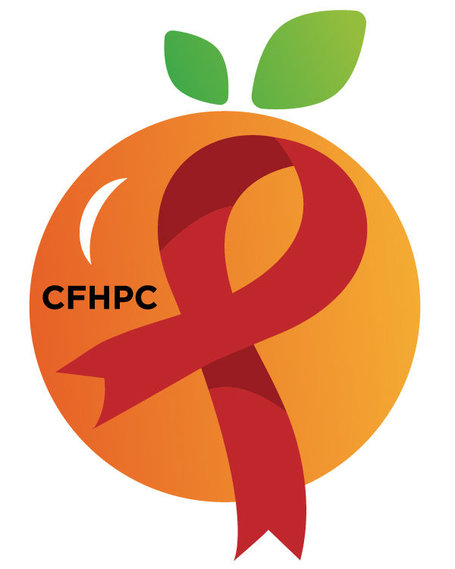

PR & Marketing Committee Agenda
Please silence all cell phones and keep usage to a minimum
Only the PLWH/A Representatives need to disclose their HIV status.
all meetings are audio recorded

October 8th, 2019

Heart of Florida United Way
10:30 AM | Call to Order  Welcome, Housekeeping & Introductions  Moment of Silence |  | Gabriella Rodriguez
 | Vision Statement  Mission Statement  Conflict of Interest |  | Roy Harry
 | Approval of Agenda  Approval of September 10th Minutes |  | Gabriella Rodriguez
 | Roberts Rules Overview |  | PCS
10:45 AM | Open the floor for Public Comment  Special Order:  Election of Chairs |  | All Members  PCS
 | Unfinished Business  Website Update & Maintenance  Red Ribbon Times Newsletter  Social Media Review | Purpose  Update  Discussion/Update  Discussion | PCS  All Members
12:00 PM | New Business  World AIDS Day Event  NLAAD  Review Work plan  Meeting Time  Set November’s Agenda | Purpose  Update  Discussion | All Members
 | Announcements  Next Month’s Meeting: November 12th, 2019 | at HFUW
12:30 PM | Adjournment
Mission: To improve the quality of life of individuals with HIV disease by responding to their existing and emerging needs, and to provide educational and behavioral strategies to reduce and prevent the spread of HIV disease.
www.ocfl.net/ryanwhite
Please join my meeting from your computer, tablet or smartphone.
Go To Meeting: https://global.gotomeeting.com/join/218791973
Teleconference Line: United States: +1 (571) 317-3112 Access Code: 218-791-973
Planning Council Support
David Bent 407-835-0906 David.Bent@hfuw.org
Melanie Cross 407 429-2216 Melanie.Cross@hfuw.org
Andres Acosta 407 429-2119 Andres.Acosta@hfuw.org

United Way Website: www.RyanWhiteCFAP.org
Orange County Website: www.ocfl.net/ryanwhite
Facebook: www.facebook.com/CentralFloridaHIVPlanningCouncil

