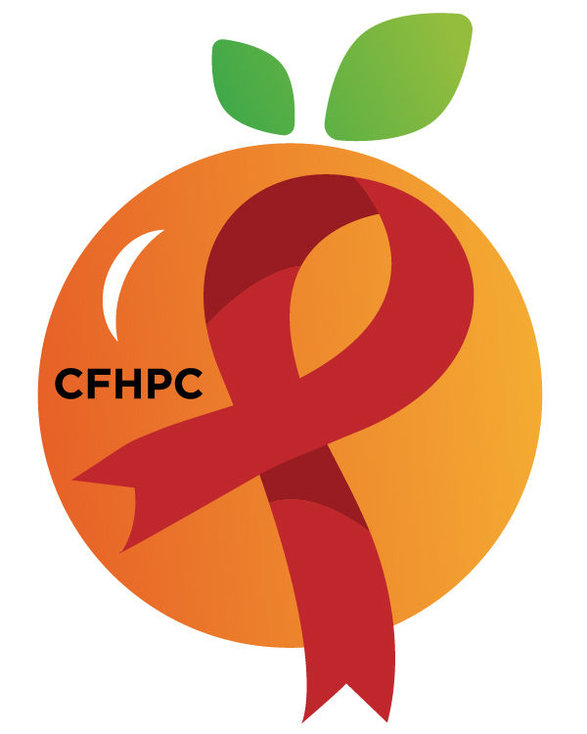

Membership Committee Agenda
Please silence all cell phones and keep usage to a minimum
Only the PLWH/A Representatives need to disclose their HIV status.
all meetings are audio recorded

November 5th, 2019

Heart of Florida United Way
2:00 PM | Call to Order  Welcome, Housekeeping & Introductions  Moment of Silence |  | Jessica Seidita
 | Vision Statement  Mission Statement  Conflict of Interest |  | Earl Hunt
 | Approval of Agenda  Approval of October 1st Minutes |  | Jessica Seidita
 | Roberts Rules Overview |  | PCS
 | Open the floor for Public Comment  Mini Training  Organizational Culture |  | All Members  PCS
 | Reports  - Membership Matrix  - Committee Roster  - PC Reflectiveness  - Attendance Roster | Purpose  Info Sharing | All Members
 | Unfinished Business  Recruitment Policy & Procedure  Recruitment Activities  Member Training Schedule | Purpose  Review/Revisions | PCS
 | New Business  Recruitment Policy & Procedure  Orientation Evaluation  Applicant Summaries  Set January’s Agenda | Purpose  Review  Voting/Update  Discussion/Update | PCS  All Members
 | Next Month’s Meeting: January 7th | at HFUW
4:00 PM | Adjournment
Mission: To improve the quality of life of individuals with HIV disease by responding to their existing and emerging needs, and to provide educational and behavioral strategies to reduce and prevent the spread of HIV disease.
www.ocfl.net/ryanwhite
Please join my meeting from your computer, tablet or smartphone.
Go To Meeting: https://global.gotomeeting.com/join/508386453
Teleconference Line: +1 (646) 749-3122; Access Code: 508-386-453

Planning Council Support
David Bent 407-835-0906 David.Bent@hfuw.org
Melanie Cross 407 429-2216 Melanie.Cross@hfuw.org
Andres Acosta 407 429-2119 Andres.Acosta@hfuw.org

Orange County Website: www.ocfl.net/ryanwhite
Facebook: www.facebook.com/CentralFloridaHIVPlanningCouncil

