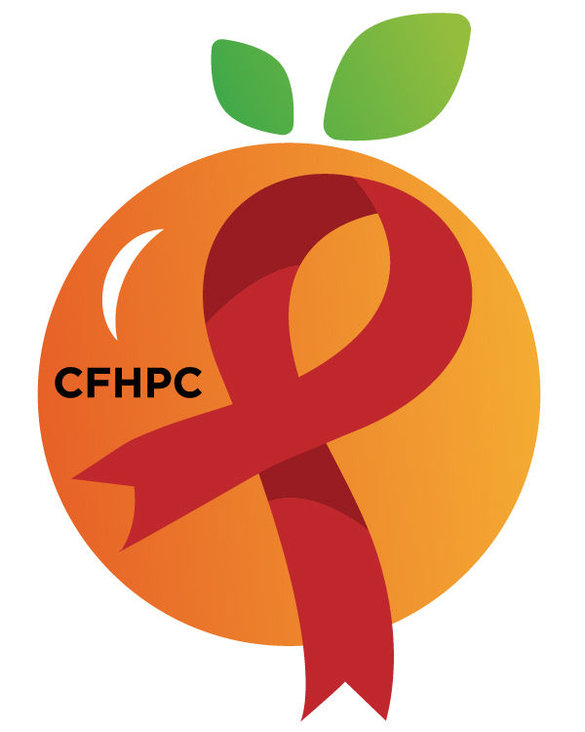

PR & Marketing Committee Agenda
Please silence all cell phones and keep usage to a minimum
Only the PLWH/A Representatives need to disclose their HIV status.
all meetings are audio recorded

November 12th, 2019

Heart of Florida United Way
10:30 AM | Call to Order  Welcome, Housekeeping & Introductions  Moment of Silence |  | Gabriella Rodriguez
 | Vision Statement  Mission Statement  Conflict of Interest |  | Roy Harry
 | Approval of Agenda  Approval of October 8th Minutes |  | Gabriella Rodriguez
 | Roberts Rules Overview |  | PCS
10:45 AM | Open the floor for Public Comment |  | All Members
 | Unfinished Business  World AIDS Day  Social Media Review  Red Ribbon Times Newsletter  Educational Info Graphic | Purpose  Update  Discussion | PCS All Members
12:00 PM | New Business  Marketing Plan  Recruitment P&P  CFHPC Website  Set January’s Agenda | Purpose  30 Day Review  Discussion | All Members
 | Announcements  Next Month’s Meeting: January 14th, 2020 | at HFUW
12:30 PM | Adjournment
Mission: To improve the quality of life of individuals with HIV disease by responding to their existing and emerging needs, and to provide educational and behavioral strategies to reduce and prevent the spread of HIV disease.
www.ocfl.net/ryanwhite
Please join my meeting from your computer, tablet or smartphone.
Go To Meeting: https://global.gotomeeting.com/join/218791973
Teleconference Line: United States: +1 (571) 317-3112 Access Code: 218-791-973
Planning Council Support
David Bent 407-835-0906 David.Bent@hfuw.org
Melanie Cross 407 429-2216 Melanie.Cross@hfuw.org
Andres Acosta 407 429-2119 Andres.Acosta@hfuw.org

United Way Website: www.RyanWhiteCFAP.org
Orange County Website: www.ocfl.net/ryanwhite
Facebook: www.facebook.com/CentralFloridaHIVPlanningCouncil

