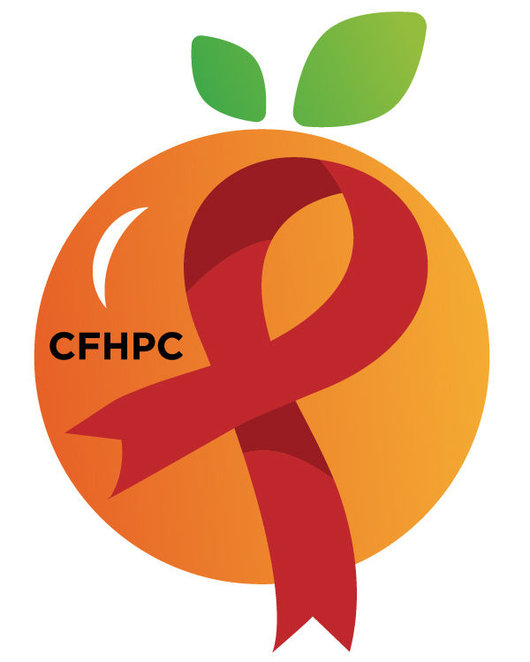

Service Systems & Quality Committee Agenda
Please silence all cell phones or keep usage to a minimum
Only the PLWH/A Representatives need to disclose their HIV status.
all meetings are audio recorded

February 6th, 2020

Heart of Florida United Way
10:00 AM | Call to Order  Welcome, Housekeeping & Introductions  Moment of Silence |  | Maria Buckley
 | Vision Statement  Mission Statement  Conflict of Interest  Core Values |  | Earl Hunt
 | Approval of Agenda  Approval of January 9th Minutes |  | Maria Buckley
 | Roberts Rules Overview  FCPN Announcement  CFHPC Text Line |  | PCS
 | Open the floor for Public Comment  Mini Training  Survey Validity |  | All Members  PCS
10:15 AM | Reports  Quarterly Part A Utilization Report  CQM Update  Unfinished Business  Service Standards  OAHS  Medical Nutrition  Disparties and Outcomes | Purpose  Info Sharing  Review/Update  Discuss | Alelia Munroe  Yasmin AndreAlelia Munroe  PCS  All Members
11:15 AM | New Business  Service Standards  System Wide  AAM  Special Studies  Analyze Needs Assessment Results  Set March’s Agenda | Voting  Discussion  Update | All Members
 | Announcements  Next Month’s Meeting: March 5th, 2020 | at HFUW
12:00 PM | Adjournment
Mission: To improve the quality of life of individuals with HIV disease by responding to their existing and emerging needs, and to provide educational and behavioral strategies to reduce and prevent the spread of HIV disease.
www.ocfl.net/ryanwhite

Go To Meeting: https://global.gotomeeting.com/join/718434797
Teleconference Line: +1 (224) 501-3412; Access Code: 718-434-797
Planning Council Support
David Bent 407-835-0906 David.Bent@hfuw.org
Melanie Cross 407 429-2216 Melanie.Cross@hfuw.org
Andres Acosta 407 429-2119 Andres.Acosta@hfuw.org
CFHPC Website: www.CentralFloridaHIVPC.com
Orange County Website: www.ocfl.net/ryanwhite
Facebook: www.facebook.com/CentralFloridaHIVPlanningCouncil

