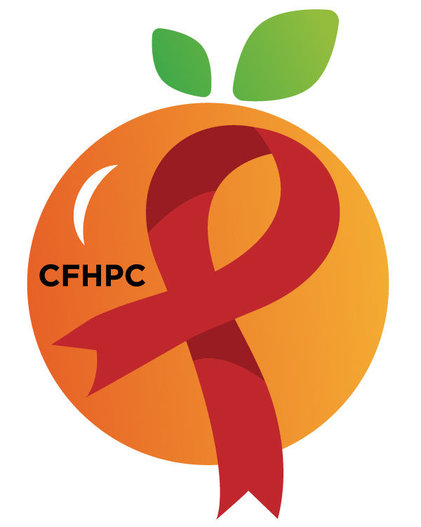

Service Systems & Quality Committee Agenda
Please silence all cell phones or keep usage to a minimum
Only the PLWH/A Representatives need to disclose their HIV status.
all meetings are audio recorded

January 9th, 2019

Heart of Florida United Way
10:00 AM | Call to Order  Welcome, Housekeeping & Introductions  Moment of Silence |  | Maria Buckley
 | Vision Statement  Mission Statement  Conflict of Interest |  | Earl Hunt
 | Approval of Agenda  Approval of November 7th Minutes |  | Maria Buckley
 | Roberts Rules Overview |  | PCS
 | Open the floor for Public Comment |  | All Members
10:15 AM | Reports  Quarterly Part B Utilization Report | Purpose  Info Sharing | Hamad Shivji & Jannira Velazquez
 | Unfinished Business  Service Standard Tracking Plan  Medicaid Update  Integrated Plan Updates  New Business  Service Standards  Medical Case Management  Outpatient Ambulatory Health Services (OAHS)  Medical Nutritional Therapy | Discuss  Review/Update  Discuss | All Members
11:15 AM | Leadership Evaluations  Set February’s Agenda | Voting  Discussion | All Members
 | Announcements  Next Month’s Meeting: February 6th, 2020  New Street Name, Same Location | at HFUW
12:00 PM | Adjournment
Mission: To improve the quality of life of individuals with HIV disease by responding to their existing and emerging needs, and to provide educational and behavioral strategies to reduce and prevent the spread of HIV disease.

Go To Meeting: https://global.gotomeeting.com/join/718434797
Teleconference Line: +1 (224) 501-3412; Access Code: 718-434-797
Planning Council Support
David Bent 407-835-0906 David.Bent@hfuw.org
Melanie Cross 407 429-2216 Melanie.Cross@hfuw.org
Andres Acosta 407 429-2119 Andres.Acosta@hfuw.org

Orange County Website: www.ocfl.net/ryanwhite
Facebook: www.facebook.com/CentralFloridaHIVPlanningCouncil

