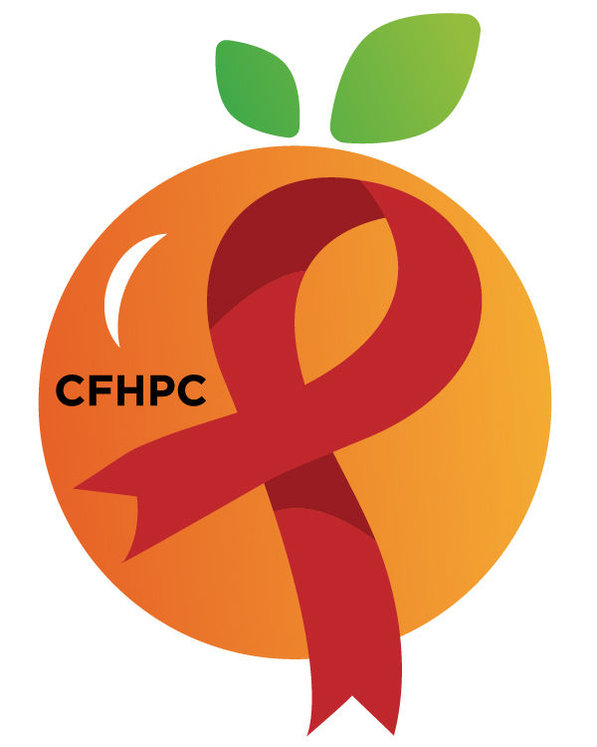

Service Systems & Quality Committee Agenda
Please silence all cell phones or keep usage to a minimum
Only the PLWH/A Representatives need to disclose their HIV status.
all meetings are audio recorded

March 5th, 2020

Heart of Florida United Way
10:00 AM | Call to Order  Welcome, Housekeeping & Introductions  Moment of Silence |  | Earl Hunt
 | Vision Statement  Mission Statement  Conflict of Interest  Core Values |  | Gertrude Adolphe
 | Approval of Agenda  Approval of February 6th Minutes |  | Earl Hunt
 | Roberts Rules Overview |  | PCS
 | Open the floor for Public Comment |  | All Members
10:15 AM | Reports  Analyze Needs Assessment Result | Purpose  Info Sharing | Andres Acosta
11:15 AM | Unfinished Business  Servicie Standards  System Wide  Integrated Plan Progress  AAM Timeline  New Business  EIS Out of Care Survey  Special Studies  Set April’s Agenda | Review/Update  Discuss  Voting  Discussion | All Members
 | Announcements  Bylaws Workgroup  Recruitment Training  Next Month’s Meeting: April 2nd, 2020 | at HFUW
12:00 PM | Adjournment
Mission: To improve the quality of life of individuals with HIV disease by responding to their existing and emerging needs, and to provide educational and behavioral strategies to reduce and prevent the spread of HIV disease.

Go To Meeting: https://global.gotomeeting.com/join/718434797
Teleconference Line: +1 (224) 501-3412; Access Code: 718-434-797
Planning Council Support
David Bent 407-835-0906 David.Bent@hfuw.org
Melanie Cross 407 429-2216 Melanie.Cross@hfuw.org
Andres Acosta 407 429-2119 Andres.Acosta@hfuw.org
CFHPC Website: www.CentralFloridaHIVPC.com
Orange County Website: www.ocfl.net/ryanwhite
Facebook: www.facebook.com/CentralFloridaHIVPlanningCouncil

