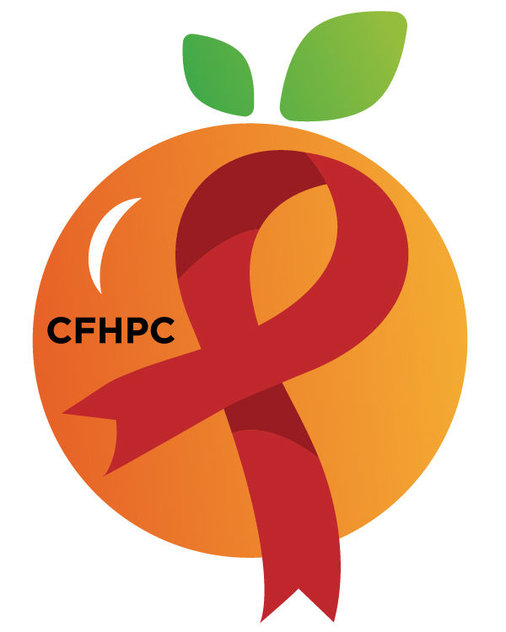

Needs Assessment Committee Agenda
Please turn all cell phones on silent and keep usage to a minimum
Only the PLWH/A Representatives need to disclose their HIV status.
all meetings are audio recorded

March 12th, 2020

Heart of Florida United Way
2:00 PM | Call to Order  Welcome, Housekeeping & Introductions  Moment of Silence |  | Tim Collins
 | Vision Statement  Mission Statement  Conflict of Interest  Core Values |  | Ira Westbrook
 | Approval of Agenda  Approval of February 13TH Minutes |  | Tim Collins
 | Roberts Rules Overview |  | PCS
2:15 PM | Open the floor for Public Comment  Special Studies Mini Training |  | All Members  PCS
 | Reports  Part A Monthly Expenditure & Procurement Report  Part B Monthly Expenditure | Purpose  Review | Yvette Reyes/Ivonne Velez  Jannira Velazquez
2:50 PM | Unfinished Business  Needs Assessment Process  Integrated Plan Progress & Implementation Plan  Recommend Special Studies/Projects  Emerging Policies | Purpose  Implement or  Monitor  Update | All Members
3:15 PM | New Business  Set March’s Agenda | Purpose
 | Announcements
4:00 PM | Adjournment  Next Month’s Meeting: April 9th, 2020 at HFUW
Mission: To improve the quality of life of individuals with HIV disease by responding to their existing and emerging needs, and to provide educational and behavioral strategies to reduce and prevent the spread of HIV disease.

Please join my meeting from your computer, tablet or smartphone.
Go To Meeting: https://global.gotomeeting.com/join/857804621
Teleconference Line: United States: +1 (571) 317-3122 Access Code: 857-804-621
Planning Council Support
David Bent 407-835-0906 David.Bent@hfuw.org
Melanie Cross 407 429-2216 Melanie.Cross@hfuw.org
Andres Acosta 407 429-2119 Andres.Acosta@hfuw.org

CFHPC Website: www.CentralFloridaHIVPC.com
Orange County Website: www.ocfl.net/ryanwhite
Facebook: www.facebook.com/CentralFloridaHIVPlanningCouncil

