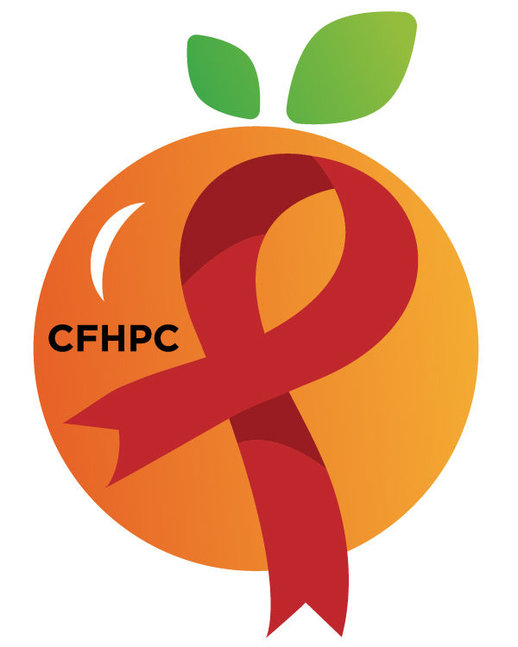

Needs Assessment Committee Agenda
Please turn all cell phones on silent and keep usage to a minimum
Only the PLWH/A Representatives need to disclose their HIV status.
all meetings are audio recorded

October 10, 2019

Heart of Florida United Way
3:00 PM | Call to Order  Welcome, Housekeeping & Introductions  Moment of Silence |  | Tim Collins
 | Vision Statement  Mission Statement  Conflict of Interest |  | Ira Westbrook
 | Approval of Agenda  Approval of September 12th Minutes |  | Tim Collins
 | Roberts Rules Overview  Mini Training:  RFP Mini Training |  | PCS
3:35 PM | Open the floor for Public Comment  Special Order:  Election of Chairs |  | All Members
 | Reports  Part A Monthly Expenditure Report  Part B Monthly Expenditure Report | Purpose  Review & Update | Yvette Reyes/Ivonne Velez  Yasmin Andre
4:10 PM | Unfinished Business  - Quality Management | Purpose  Update | All Members
 | New Business  Data Presentation, Priority Setting & Process  Update DP, PS Process  New Meeting Time  Set November Agenda | Purpose  Review | All Members
 | Announcements
4:00 PM | Adjournment  Next Month’s Meeting: November 14th, 2019 at HFUW
Mission: To improve the quality of life of individuals with HIV disease by responding to their existing and emerging needs, and to provide educational and behavioral strategies to reduce and prevent the spread of HIV disease.
www.ocfl.net/ryanwhite

Please join my meeting from your computer, tablet or smartphone.
Go To Meeting: https://global.gotomeeting.com/join/857804621
Teleconference Line: United States: +1 (571) 317-3122 Access Code: 857-804-621
Planning Council Support
David Bent 407-835-0906 David.Bent@hfuw.org
Melanie Cross 407 429-2216 Melanie.Cross@hfuw.org
Andres Acosta 407 429-2119 Andres.Acosta@hfuw.org

Orange County Website: www.ocfl.net/ryanwhite
Facebook: www.facebook.com/CentralFloridaHIVPlanningCouncil

