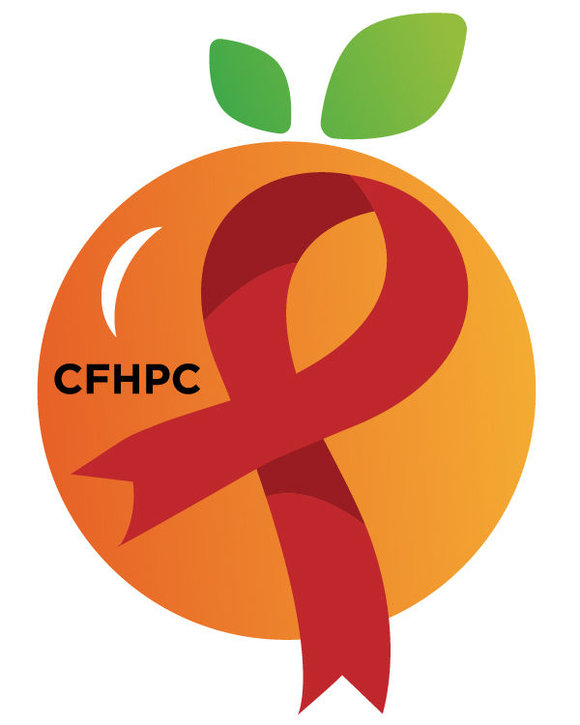

Service Systems & Quality Committee Agenda
Please silence all cell phones or keep usage to a minimum
Only the PLWH/A Representatives need to disclose their HIV status.
all meetings are audio recorded

November 7th, 2019

Heart of Florida United Way
10:00 AM | Call to Order  Welcome, Housekeeping & Introductions  Moment of Silence |  | Maria Buckley
 | Vision Statement  Mission Statement  Conflict of Interest |  | Maria Buckley
 | Approval of Agenda  Approval of October 3rd Minutes |  | Maria Buckley
 | Roberts Rules Overview |  | PCS
 | Open the floor for Public Comment |  | All Members
10:15 AM | Reports  Part A Quarterly Utilization Report  Medicaid Report  Quality Management Update  Unfinished Business  Resource Allocation  Process  Evaluation Forms  Integrated Plan Progress | Purpose  Information Sharing  Review/Update  Discuss | Alelia Munroe  Gisela Hernandez  Hamad Shivji  All Members
11:15 AM | New Business  Service Standard Tracking Plan  Service Standards  Oral Health  Substance Abuse Residential  Out of care study  AAM  Set January’s Agenda | Voting  Discussion | All Members
 | Announcements  Next Month’s Meeting: January 9nd, 2020 | at HFUW
12:00 PM | Adjournment
Mission: To improve the quality of life of individuals with HIV disease by responding to their existing and emerging needs, and to provide educational and behavioral strategies to reduce and prevent the spread of HIV disease.
www.ocfl.net/ryanwhite

Go To Meeting: https://global.gotomeeting.com/join/718434797
Teleconference Line: +1 (224) 501-3412; Access Code: 718-434-797
Planning Council Support
David Bent 407-835-0906 David.Bent@hfuw.org
Melanie Cross 407 429-2216 Melanie.Cross@hfuw.org
Andres Acosta 407 429-2119 Andres.Acosta@hfuw.org
United Way Website: www.RyanWhiteCFAP.org
Orange County Website: www.ocfl.net/ryanwhite
Facebook: www.facebook.com/CentralFloridaHIVPlanningCouncil

