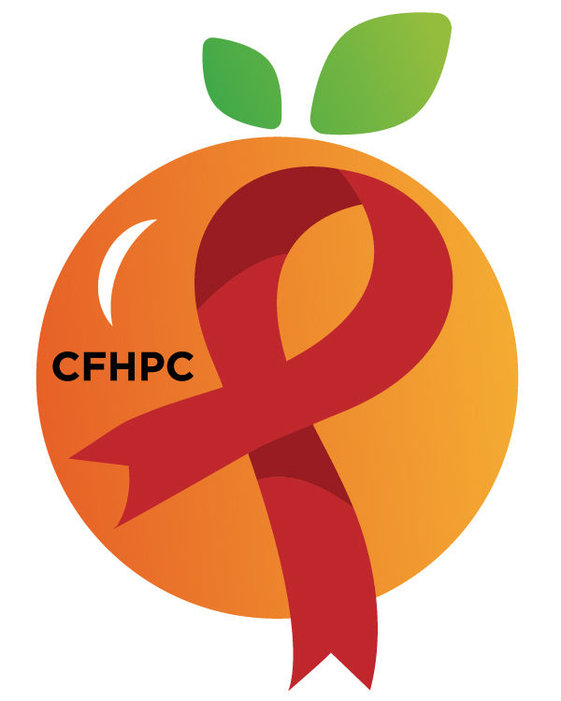

Needs Assessment Committee Agenda
Please turn all cell phones on silent and keep usage to a minimum
Only the PLWH/A Representatives need to disclose their HIV status.
all meetings are audio recorded

November 14, 2019

Heart of Florida United Way
2:00 PM | Call to Order  Welcome, Housekeeping & Introductions  Moment of Silence |  | Tim Collins
 | Vision Statement  Mission Statement  Conflict of Interest |  | Ira Westbrook
 | Approval of Agenda  Approval of October 10th Minutes |  | Tim Collins
 | Roberts Rules Overview |  | PCS
 | Open the floor for Public Comment |  | All Members
 | Reports  Part A Monthly Expenditure Report  Part A Quarterly Utilization Report  Part A Reallocation Request  Part B Monthly Expenditure Report  Quality Management | Purpose  Info Sharing | Yvette Reyes/Ivonne Velez  Yasmin Andre  Hamad Shivji
 | Unfinished Business  2017-2021 Integrated Plan Progress  Recommend Updates  Recommend Special Studies/Projects | Purpose  Update | All Members
 | New Business  Needs Assessment Process  EIIHA Improvement Strategies  Memorandum of Understanding (MOU)  MOU W/ Key Points of Entry (KEPO) for Hospitals  Set January’s Agenda | Purpose  Review | Andres Acosta  Melanie Cross  All Members
 | Announcements
4:00 PM | Adjournment  Next Month’s Meeting: January 16th, 2020 at HFUW
Mission: To improve the quality of life of individuals with HIV disease by responding to their existing and emerging needs, and to provide educational and behavioral strategies to reduce and prevent the spread of HIV disease.
www.ocfl.net/ryanwhite

Please join my meeting from your computer, tablet or smartphone.
Go To Meeting: https://global.gotomeeting.com/join/857804621
Teleconference Line: United States: +1 (571) 317-3122 Access Code: 857-804-621
Planning Council Support
David Bent 407-835-0906 David.Bent@hfuw.org
Melanie Cross 407 429-2216 Melanie.Cross@hfuw.org
Andres Acosta 407 429-2119 Andres.Acosta@hfuw.org

Orange County Website: www.ocfl.net/ryanwhite
Facebook: www.facebook.com/CentralFloridaHIVPlanningCouncil

