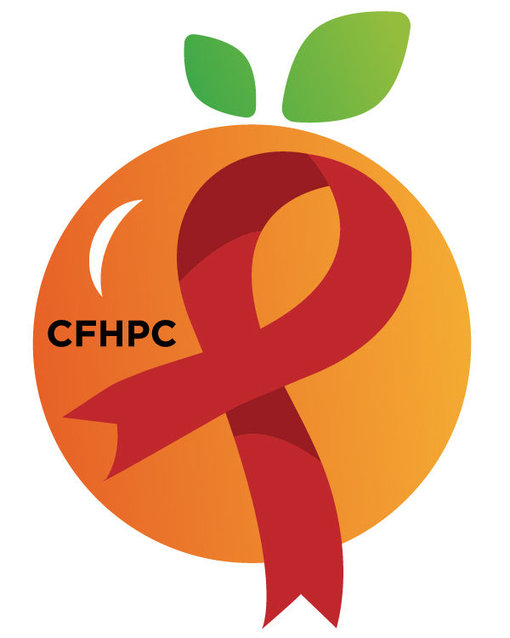

Service Systems & Quality Committee Agenda
Please silence all cell phones or keep usage to a minimum
Only the PLWH/A Representatives need to disclose their HIV status.
all meetings are audio recorded

October 3rd, 2019

Heart of Florida United Way
10:00 AM | Call to Order  Welcome, Housekeeping & Introductions  Moment of Silence |  | Earl Hunt
 | Vision Statement  Mission Statement  Conflict of Interest |  | Sam Graper
 | Meeting Purpose Statement  Approval of Agenda  Approval of September 5th Minutes |  | Melanie Cross Earl Hunt
 | Roberts Rules Overview |  | PCS
 | Open the floor for Public Comment  Special Order:  Election of Chair & Vice Chair |  | All Members
10:15 AM | Unfinished Business  Data Presentation  Evaluations  Evaluation Forms  Process  Priority Setting Evaluations  Evaluations  Evaluation Forms  Process  Resource Allocation  Process  Evaluation Forms  Integrated Plan Progress | Purpose  Review/Update  Discuss  Review/Update | All Members
11:15 AM | New Business  Develop 2019-2020 Work Plan  Service Standards  Oral Health  Substance Abuse Residential  Meeting Time  Set Novembers Agenda | Voting  Discussion
 | Announcements  Next Month’s Meeting: November 7th, 2019 | at HFUW
12:00 PM | Adjournment
Mission: To improve the quality of life of individuals with HIV disease by responding to their existing and emerging needs, and to provide educational and behavioral strategies to reduce and prevent the spread of HIV disease.
www.ocfl.net/ryanwhite

Go To Meeting: https://global.gotomeeting.com/join/718434797
Teleconference Line: +1 (224) 501-3412; Access Code: 718-434-797
Planning Council Support
David Bent 407-835-0906 David.Bent@hfuw.org
Melanie Cross 407 429-2216 Melanie.Cross@hfuw.org
Andres Acosta 407 429-2119 Andres.Acosta@hfuw.org
United Way Website: www.RyanWhiteCFAP.org
Orange County Website: www.ocfl.net/ryanwhite
Facebook: www.facebook.com/CentralFloridaHIVPlanningCouncil

