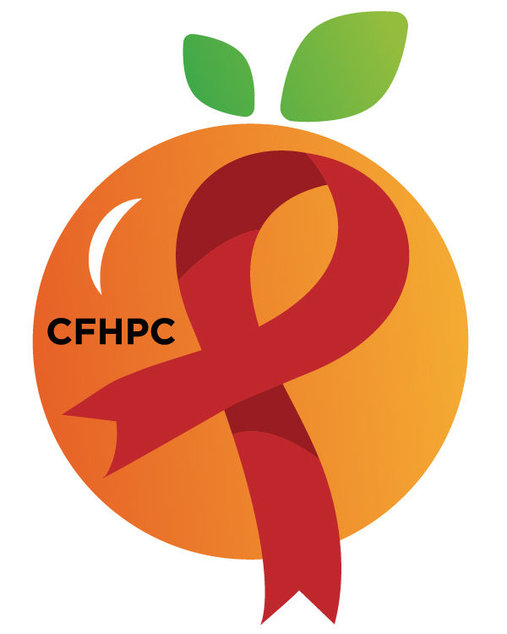

PR & Marketing Committee Agenda
Please silence all cell phones and keep usage to a minimum
Only the PLWH/A Representatives need to disclose their HIV status.
all meetings are audio recorded

July 14, 2020

Heart of Florida United Way
10:30 AM | Call to Order  Welcome, Housekeeping & Introductions  Moment of Silence |  | Gabriella Rodriguez
 | Vision Statement  Mission Statement  Conflict of Interest  Core Values |  | Roy Harry
 | Approval of Agenda  Approval of March 10th Minutes |  | Gabriella Rodriguez
 | Roberts Rules Overview  Open the Floor for Public Comment |  | PCS
10:45 AM | Unfinished Business  Website Update  Social Media  Facebook  Instagram  Red Ribbon Times Newsletter(RRT)  Marketing Plan  Infographic Discussion  Pride Virtual Event | Purpose  Update  Discussion | PCS  All Members
12:00 PM | New Business  Upcoming RRT  Policies and Procedures  World AIDS Day  Set Augusts Agenda | Purpose  Discussion | All Members
 | Announcements  Next Month’s Meeting: August 11, 2020 | at HFUW
12:30 PM | Adjournment
Mission: To improve the quality of life of individuals with HIV disease by responding to their existing and emerging needs, and to provide educational and behavioral strategies to reduce and prevent the spread of HIV disease.
Please join my meeting from your computer, tablet or smartphone.
Go To Meeting: https://global.gotomeeting.com/join/218791973
Teleconference Line: United States: +1 (571) 317-3112 Access Code: 218-791-973
Planning Council Support
Melanie Cross 407 429-2216 Melanie.Cross@hfuw.org
Andres Acosta 407 429-2119 Andres.Acosta@hfuw.org
David Bent 407-835-0906 David.Bent@hfuw.org

CFHPC Website: www.CentralFloridaHIVPC.com
Orange County Website: www.ocfl.net/ryanwhite
Facebook: www.facebook.com/CentralFloridaHIVPlanningCouncil

