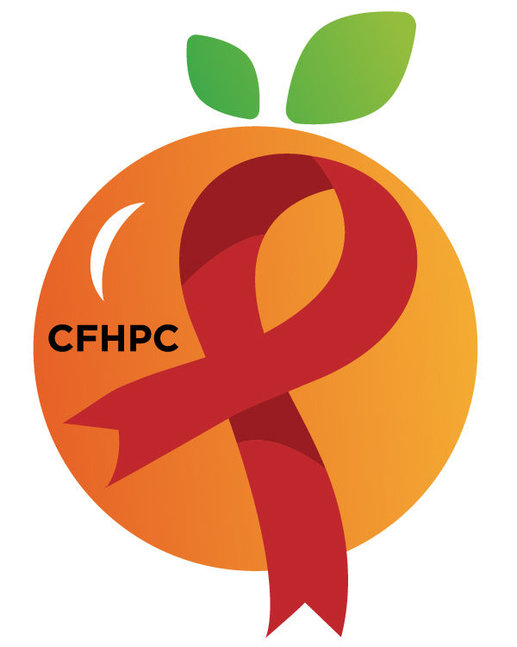

Service Systems & Quality Committee Agenda
Please KEEP YOUR LINES MUTED IF YOU’re not speaking. Need help connecting? Text 407-901-1473
Only the PLWH/A Representatives need to disclose their HIV status.
all meetings are audio recorded

^{September 15th}, 2020

Heart of Florida United Way
10:00 AM | Call to Order  Welcome, Housekeeping & Introductions  Moment of Silence |  | Sam Graper
 | Vision Statement  Mission Statement  Conflict of Interest |  | Maria Buckley
 | Approval of Agenda  Approval of August 6th Minutes |  | Sam Graper
 | Roberts Rules Overview |  | PCS
 | Open the floor for Public Comment |  | All Members
10:15 AM | Reports  TBD  Unfinished Business  Integrated Plan Progress  Service Standards  System Wide Service Standards  Nominate Chair and Vice Chair  Leadership Evaluations  Evaluation Tools for Data Presentation, Priority Setting, and Resource Allocation  Annual Committee Report | Purpose  Review/Info Sharing  Update | PCS  All Members  All Members
11:15 AM | New Business  Set October’s Agenda | Discussion | All Members
 | Announcements  Next Month’s Meeting: October 1st, 2020 | Virtual
12:00 PM | Adjournment
Mission: To improve the quality of life of individuals with HIV disease by responding to their existing and emerging needs, and to provide educational and behavioral strategies to reduce and prevent the spread of HIV disease.
www.ocfl.net/ryanwhite

Go To Meeting: https://global.gotomeeting.com/join/718434797
Teleconference Line: +1 (224) 501-3412; Access Code: 718-434-797
Planning Council Support
David Bent 407-835-0906 David.Bent@hfuw.org
Melanie Cross 407 429-2216 Melanie.Cross@hfuw.org
Andres Acosta 407 429-2119 Andres.Acosta@hfuw.org
CFHPC Website: www.CentralFloridaHIVPC.com
Orange County Website: www.ocfl.net/ryanwhite
Facebook: www.facebook.com/CentralFloridaHIVPlanningCouncil

