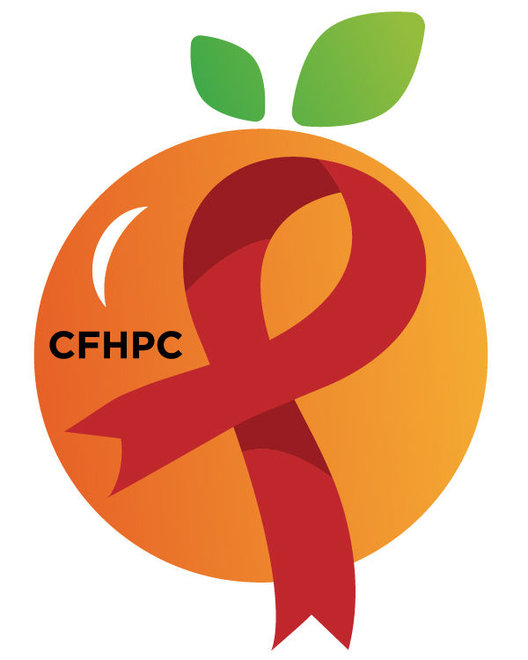

Service Systems & Quality Committee Agenda
Please KEEP YOUR LINES MUTED IF YOU’re not speaking. Need help connecting? Text 407-901-1473
Only the PLWH/A Representatives need to disclose their HIV status.
all meetings are audio recorded

October 8, 2020

Heart of Florida United Way
10:00 AM | Call to Order  Welcome, Housekeeping & Introductions  Moment of Silence |  | Angie Buckley
 | Vision Statement  Mission Statement  Conflict of Interest  Core Values |  | Andres Acosta
 | Approval of Agenda  Approval of September 15th Minutes |  | Angie Buckley
 | Roberts Rules Overview |  | PCS
 | Open the floor for Public Comment  Special Order: Election of Chairs |  | All Members
10:15 AM | Reports  Unfinished Business  TBD  Service Standards  TBD | Purpose  Review/Info Sharing | Alelia Munroe  All Members
11:15 AM | New Business  Data Presentation & PSRA Evaluations  Evaluation Forms  Committee Work Plan  New Meeting Time | Assess Results  Update  Vote | All Members
 | Announcements  Next Month’s Meeting: November 5th, 2020 | Virtual
12:00 PM | Adjournment
Mission: To improve the quality of life of individuals with HIV disease by responding to their existing and emerging needs, and to provide educational and behavioral strategies to reduce and prevent the spread of HIV disease.
www.ocfl.net/ryanwhite

Go To Meeting: https://global.gotomeeting.com/join/718434797
Teleconference Line: +1 (224) 501-3412; Access Code: 718-434-797
Planning Council Support
David Bent 407-835-0906 David.Bent@hfuw.org
Melanie Cross 407 429-2216 Melanie.Cross@hfuw.org
Andres Acosta 407 429-2119 Andres.Acosta@hfuw.org
CFHPC Website: www.CentralFloridaHIVPC.com
Orange County Website: www.ocfl.net/ryanwhite
Facebook: www.facebook.com/CentralFloridaHIVPlanningCouncil

