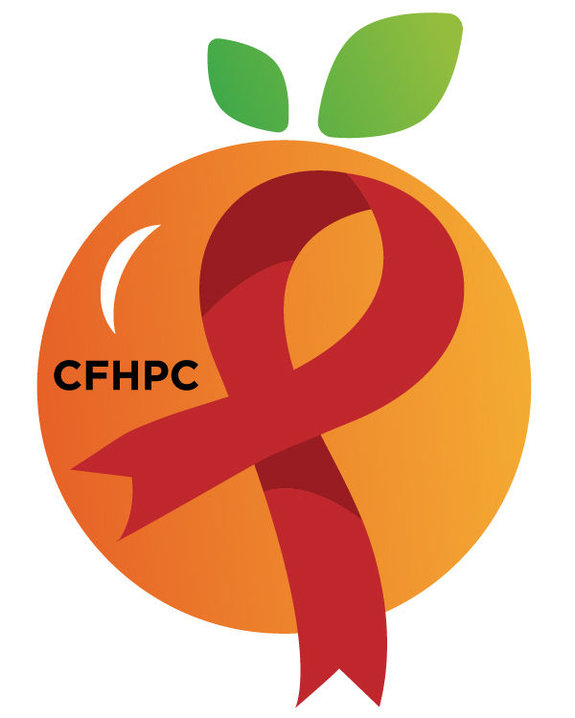
RYAN WHITE COMMUNITY MEETING
Please turn all cell phones on silent and keep usage to a minimum
Only the PLWH/A Representatives need to disclose their HIV status.
all meetings are audio recorded
Core Values: Empowerment, commitment, quality & integrity
February 16th, 2021
946 N Mills Ave
6:00 PM | Call to Order  Welcome, Housekeeping & Introductions  Moment of Silence |  | Vel Cline
 | Vision Statement  Mission Statement  Conflict of Interest  Core Values |  | Dean Hutchins
 | Approval of Agenda  Approval of January 19, Minutes |  | Vel Cline
 | Consensus Building Overview |  | PCS
6:15 PM | Open the floor for Public Comment |  | All Participants
 | Reports  Membership Committee  SSQ  PR & Marketing  Service Systems & Quality Committee | Purpose  Info Sharing | Dean Hutchins  Ok
7:15 PM | New Business  Service Standards TBD  TBD  Set March’s Agenda | Purpose  Info Sharing  Discussion | PCS
 | Announcements
8:00 PM | Adjournment  Next Month’s Meeting: February 16th

Mission: To improve the quality of life of individuals with HIV disease by responding to their existing and emerging needs, and to provide educational and behavioral strategies to reduce and prevent the spread of HIV disease.

Ryan White Community Meeting
Please join my meeting from your computer, tablet or smartphone.
https://global.gotomeeting.com/join/675944325
United States: +1 (646) 749-3122: Access Code: 675-944-325
Planning Council Support
David Bent 407-835-0906 David.Bent@hfuw.org
Melanie Cross 407 429-2216 Melanie.Cross@hfuw.org
Andres Acosta 407 429-2119 Andres.Acosta@hfuw.org

CFHPC Website: www.CentralFloridaHIVPC.com
Orange County Website: www.ocfl.net/ryanwhite
Facebook: www.facebook.com/CentralFloridaHIVPlanningCouncil

