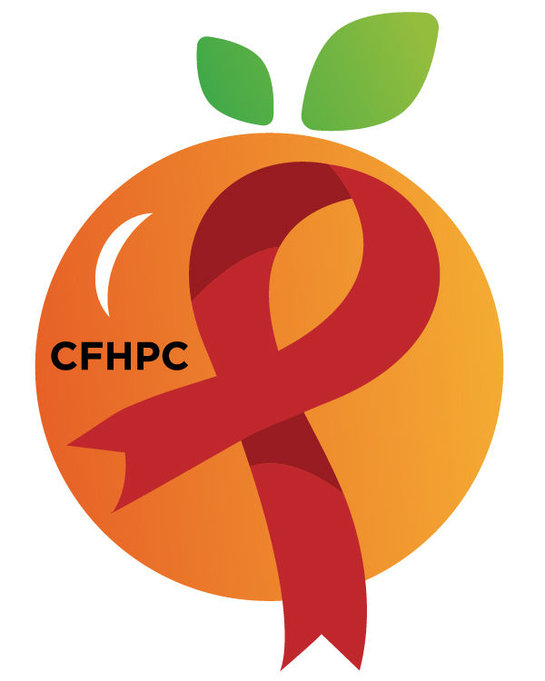
RYAN WHITE COMMUNITY MEETING
Please turn all cell phones on silent and keep usage to a minimum
Only the PLWH/A Representatives need to disclose their HIV status.
all meetings are audio recorded
Core Values: Empowerment, commitment, quality & integrity
October 20, 2020

Virtual via GoTo Meeting
6:00 PM | Call to Order  Welcome, Housekeeping & Introductions  Moment of Silence |  | Vel Cline
 | Vision Statement  Mission Statement  Conflict of Interest  Core Values |  | Dean Hutchins
 | Approval of Agenda  Approval of August Minutes |  | Vel Cline
 | Roberts Rules Overview |  | PCS
6:15 PM | Open the floor for Public Comment |  | All Participants
 | Reports  Membership Committee  Service Systems & Quality Committee  PR & Marketing Committee  Needs Assessment & Planning Committee  World AIDS Day Work Group | Purpose  Info Sharing | Dean Hutchins
7:15 PM | New Business  Service Standards  System Wide Service Standards  New Planning Cycle Presentations  New Meeting Time  November Meetings | Purpose  Info Sharing  Discussion | PCS

CFHPC Open House Panel

Announcements
8:00 PM | Adjournment  Next Month’s Meeting: November 17, 2020

Mission: To improve the quality of life of individuals with HIV disease by responding to their existing and emerging needs, and to provide educational and behavioral strategies to reduce and prevent the spread of HIV disease.

Ryan White Community Meeting
Please join my meeting from your computer, tablet or smartphone.
https://global.gotomeeting.com/join/675944325
United States: +1 (646) 749-3122: Access Code: 675-944-325
Planning Council Support
David Bent 407-835-0906 David.Bent@hfuw.org
Melanie Cross 407 429-2216 Melanie.Cross@hfuw.org
Andres Acosta 407 429-2119 Andres.Acosta@hfuw.org

CFHPC Website: www.CentralFloridaHIVPC.com
Orange County Website: www.ocfl.net/ryanwhite
Facebook: www.facebook.com/CentralFloridaHIVPlanningCouncil

