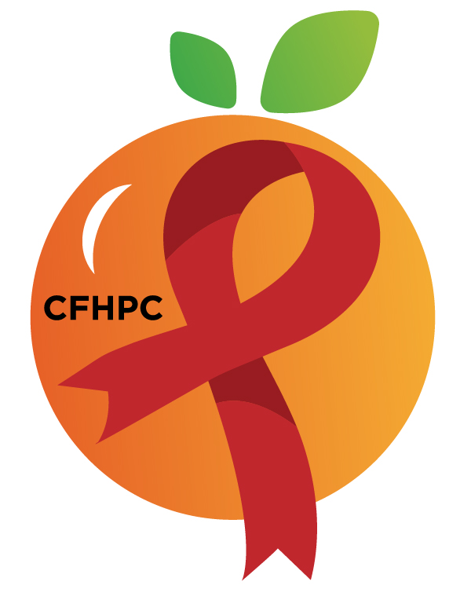
World Aids Day (WAD) WORKGROUP AGENDA
PLEASE TURN ALL CELL PHONES ON SILENT AND KEEP USAGE TO A MINIMUM
Only the PWH Representatives need to disclose their HIV status.
all meetings are audio recorded
Core Values: Empowerment, commitment, quality & integrity
April 10, 2026
Via Webex
2:00 PM | Call to Order  Welcome, Housekeeping, & Introductions  Moment of Silence  Vision & Mission Statements  Core Values  Group Agreement |  | PCS
2:00 PM | Ways to be Heard |  | PCS
2:00 PM | Approval of the Agenda  Approval of the November 25th Minutes |  | PCS
2:10 PM | Open the floor for Public Comment |  | All Participants
2:15 PM | New Business  Recap of 2025 Event  Planning and Direction of 2026 Event  Sponsorship Pack Overview | Purpose  Vote  Discussion | All Participants
3:25 PM | Announcements  Any Upcoming Community Events/Activities?
3:30 PM | Adjournment  Next Meeting: TBA

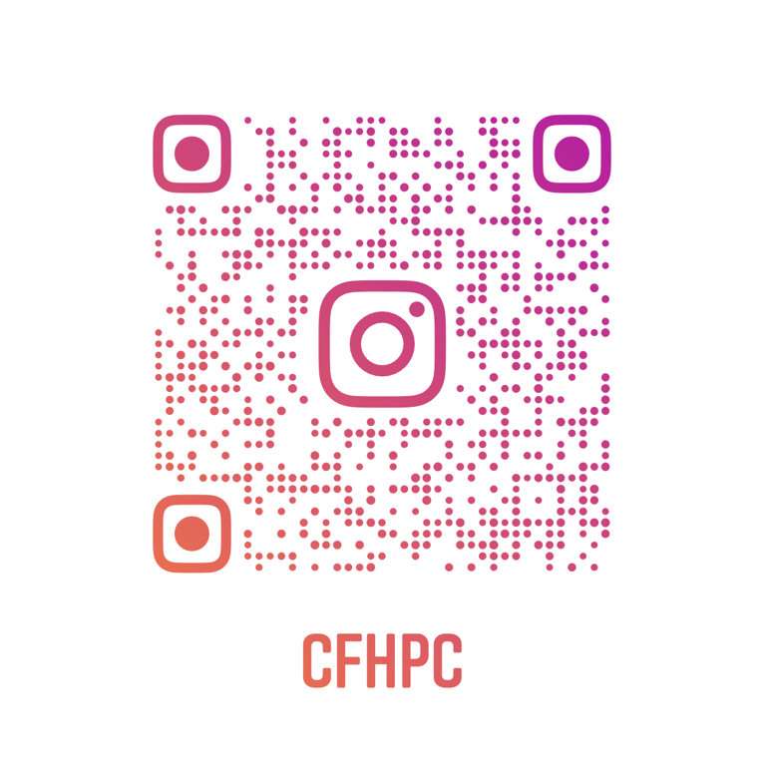
Mission: To improve the quality of life of individuals with HIV by responding to their existing and emerging needs and to provide educational and behavioral strategies to reduce and prevent the spread of HIV.
Planning Council Support
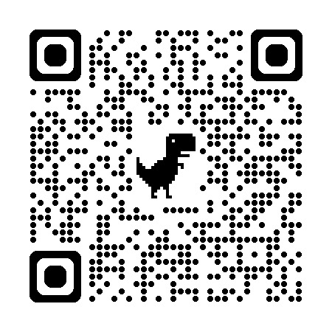
Laura Perez- 407-835-0906- Laura.Perez@hfuw.org
Whitney Marshall- 407-429-2216- Whitney.Marshall@hfuw.org

CFHPC Website: www.CentralFloridaHIVPC.com
Orange County Website: www.orangecountyfl.hiv
Facebook: www.facebook.com/CentralFloridaHIVPlanningCouncil
Instagram: https://www.instagram.com/cfhpc/?hl=en

