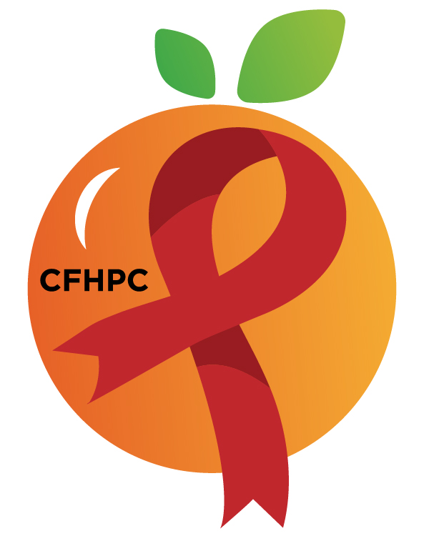

Integrated Plan Ad Hoc Committee
PLEASE KEEP LINES MUTED IF NOT SPEAKING.
Only the PWH Representatives need to disclose their HIV status.
all meetings are audio And Video recorded

Core Values: Empowerment, Commitment, Quality & Integrity

May 1, 2026

Heart of Florida United Way

1940 Cannery Way, Orlando, FL, 32804
1:00 PM | Call to Order  Welcome, Housekeeping & Introductions  Moment of Silence |  | Jessica Seidita
1:00 PM | Vision & Mission Statements  Conflict of Interest Statement  CFHPC Core Values  Group Agreement  Robert's Rules Overview  Ways to Be Heard | Please review the document in your packet for this information. If you have questions, the Chairs or PCS can assist.
1:00 PM | Approval of Agenda  Approval of April 17th Minutes |  | Beatrice Boursiquot
Open the floor for Public Comment
- Public Comment Request Forms are required before making a public comment.
1:15 PM | New Business  Review Draft Integrated Plan | Discuss & Vote | All Participants
1:55 PM | Announcements  Next Meeting: TBA  Heart of Florida United Way (1940 Cannery Way, Orlando, FL 32805)
3:00 PM | Adjournment
Mission: To improve the quality of life of individuals with HIV by responding to their existing and emerging needs, and to provide educational and behavioral strategies to reduce and prevent the spread of HIV.

Planning Council Support
Nishika Stafford: 407-429-2119- Nishika.Stafford@hfuw.org
Laura Perez: 407-835-0906 - Laura.Perez@hfuw.org
Whitney Marshall: 407-429-2216 - Whitney.Marshall@hfuw.org

CFHPC Website: www.CentralFloridaHIVPC.com
Orange County Website: www.ocfl.net/ryanwhite
Facebook: www.facebook.com/CentralFloridaHIVPlanningCouncil
Instagram: https://www.instagram.com/cfhpc/?hl=en

Scan here to view today’s meeting documents:

