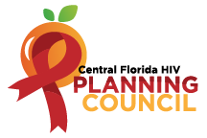
PC Vision, Mission, & Ways to be Heard
Vision Statement
A quality continuum of care for all individuals and families with, affected by, and at risk for HIV.

Mission Statement
To improve the quality of life for individuals with HIV by responding to their existing and emerging needs and to provide educational and behavioral strategies to reduce and prevent the spread of HIV.

Conflict of Interest
- An actual or perceived interest in an action that will result or has the appearance of resulting in personal, organizational, or professional gain.
- Please remember to state your conflicts before answering a question or making a statement for which a conflict might apply.

Housekeeping
- No smoking on HFUW property.
- Visitors must be accompanied by HFUW staff in the building. Please take phone calls in the front lobby or outdoor areas.
- Please only park in the designated parking spots/areas.
- Location of restrooms.
- Refreshments are on the side of the room.
- Please mute cell phones.
- If you would like to make a public comment, then a Public Comment Request Form must be filled out and given to PCS prior to the public comment section. Forms are located at the sign-in table.

Group Agreement
- Online, if you are not speaking or presenting, please keep your lines muted. (Be mindful of volume and background noise if online or on the phone).
- Respect Pronouns. Don’t pressure others or feel pressured to disclose pronouns.
- Make sure everyone has the opportunity to speak and voice opinions respectfully.
- Freely and shamelessly ask questions.
- Respect Florida Sunshine Law.
- Don’t disclose anything that you would like to be kept confidential. Meeting audios are recorded, and documents and participation are open to the public.
- Remember that everyone has different passions, experiences, barriers, and communication styles. Respect others always.
- Be mindful of others’ learning styles and processing ability.

Motion Making
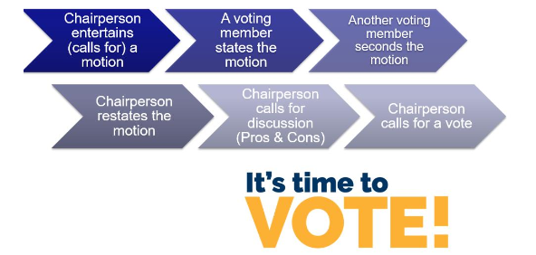

Ways to Be Heard & Public Comment Expectations
- Before/After Meetings
  - Email PCS
  - Call Planning Council Support
  - Face-to-Face meeting (before or after meetings or at a scheduled time)
- During Meetings (members of the public)
  - Public Comment Section (must fill out a form ahead of time and give to PCS)
    - Public Comment Forms can be found at the sign-in table
    - Please wait to be called on by the Chairperson
    - There is a 3-minute maximum for public comments
    - Please remember that if you have a personal concern that needs to be resolved, then PCS will connect you with an appropriate representative in the room after the meeting.
  - Announcements at the end of the meeting
- Other Ways to Be Heard
  - Participate in any open surveys

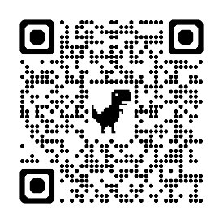
How the Planning Council Can be More Reflective of the HIV Epidemic in Central Florida
- Looking to recruit folks who are: Ryan White HIV/AIDS Program (RWHAP) clients without conflicts (i.e., does not work for a RWHAP-funded organization). Apply today by scanning the QR Code >>

