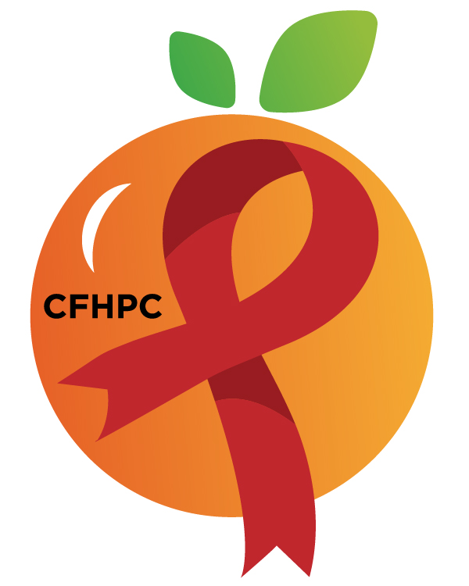

World AIDS Day Planning Meeting
Virtual: Please keep lines muted if not speaking
Physical: please silence phones and keep usage to a minimum during meetings
Only the PWH Representatives need to disclose their HIV status.
all meetings are audio and video recorded

September 11, 2026

Florida Department of Health- Lake Ellenor Location (6101 Lake Ellenor Dr., Orlando, FL 32809- Auditorium Room)

Meeting Open to Public Participation
9:30 AM | Call to Order  Welcome, Housekeeping, & Introductions  Moment of Silence  Vision, Mission, & Core Values  Statement of Conflict of Interest  Group Agreement  Motion Making & Ways to be Heard | Purpose  Info Sharing | Presenter  Kara Johnson Williams
9:30 AM | Approval of Agenda | Review & Vote | Presenter  Kara Johnson Williams
9:30 AM | Open the floor for Public Comment  - Public Comment Request Forms are required before making a public comment.
9:35 AM | World AIDS Day Workgroup Planning  - Venue Update (Set Up: Starts 2:00 PM)  - Awards Criteria and Voting Process  - Flyer Review  - Networking Hour(s) Activity Planning Cont. (Time Permitting) | Purpose  Event Planning/ Discussion | Presenter  Kara Johnson Williams
 | Announcements  Next Committee Meeting: TBA | Virtual & Physical
10:00 AM | Adjournment
Mission: To improve the quality of life of individuals with HIV by responding to their existing and emerging needs, and to provide educational and behavioral strategies to reduce and prevent the spread of HIV.

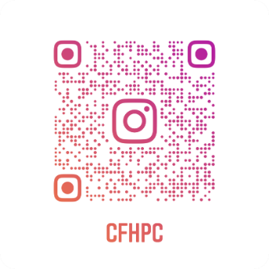
Planning Council Support

Laura Perez: 407-835-0906 - Laura.Perez@hfuw.org

Dedrah Mathis: Dedrah.Mathis@hfuw.org

Whitney Marshall: 407-429-2216 - Whitney.Marshall@hfuw.org

CFHPC Website: www.CentralFloridaHIVPC.com

Orange County Website: www.ocfl.net/ryanwhite

Facebook: www.facebook.com/CentralFloridaHIVPlanningCouncil

Instagram: https://www.instagram.com/cfhpc/?hl=en

